Name Changes in CheckMarq Step-by-Step
Changing Your “Preferred Name”: PC or Mac
Step 1. Log into CheckMarq. In the “Profile” section, click on Update info here.
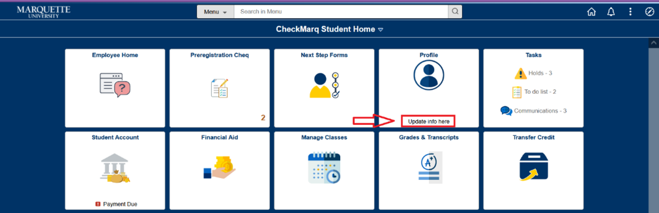
Step 2. Click on the arrow next to the box labeled “Chosen/Preferred” under Type.
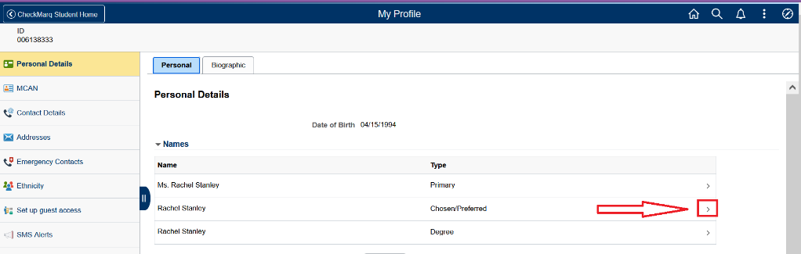
Step 3. In the Edit Name section, fill out your preferred information. When done, click the “Save” button in the upper right hand corner.
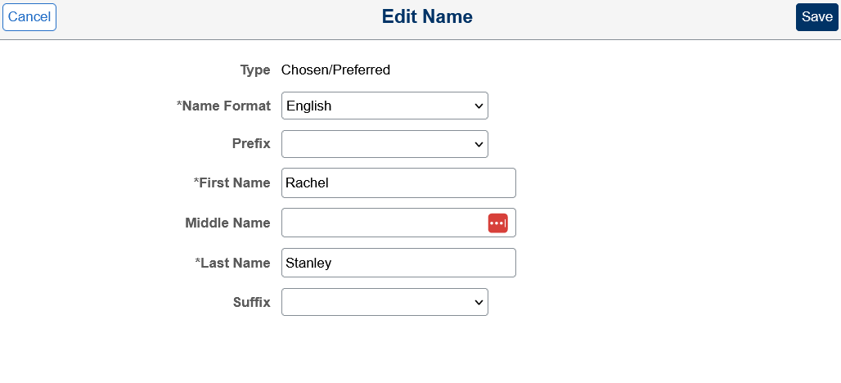
Changing Your “Preferred Name”: Mobile
Step 1. Log into CheckMarq. In the “Profile” section, click on Update info here.
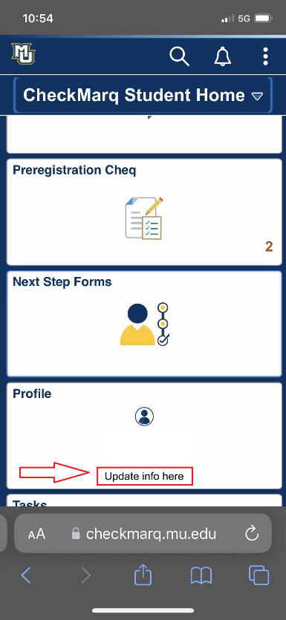
Step 2. Click on “Personal Details” at the top.
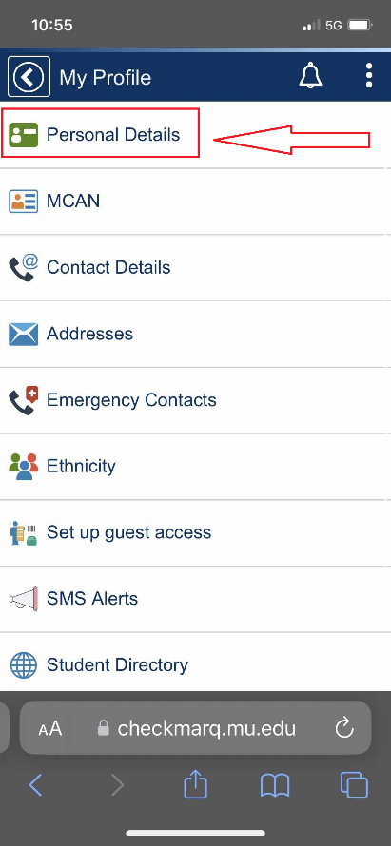
Step 3. Click on the arrow next to the box labeled “Chosen/Preferred” under Type.
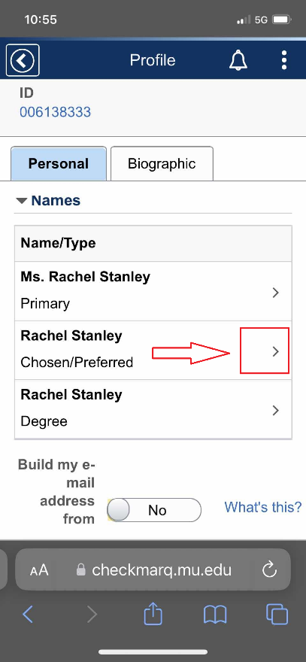
Step 4. In the Edit Name section, fill out your preferred information. When done, click the “Save” button in the upper right hand corner.
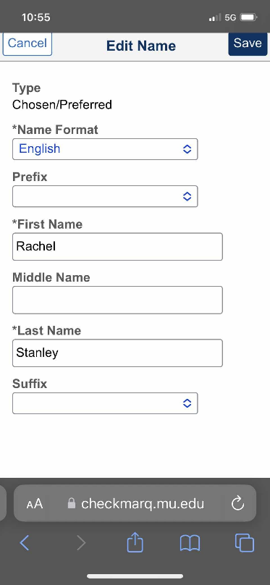

Changing Your Legal Name: PC or Mac
Step 1. Log into CheckMarq. In the “Profile” section, click on Update info here.
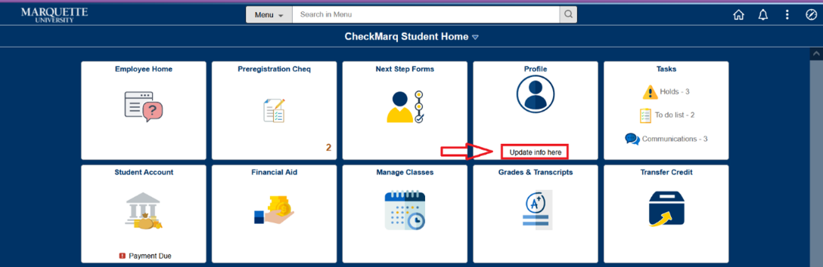
Step 2. Click on the hyperlink labeled “Marquette Central” beneath the Names box under Instructions.
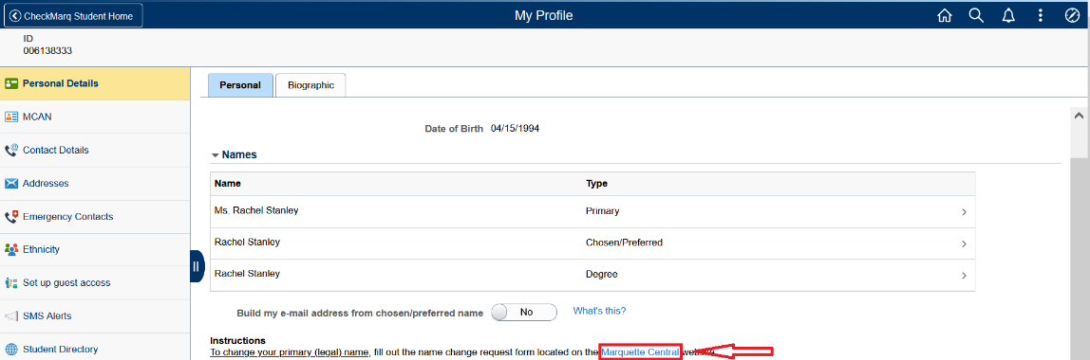
Step 3. Save the file to a location on your computer that you will be able to easily access. Open the PDF and fill it out electronically or print and fill it out.
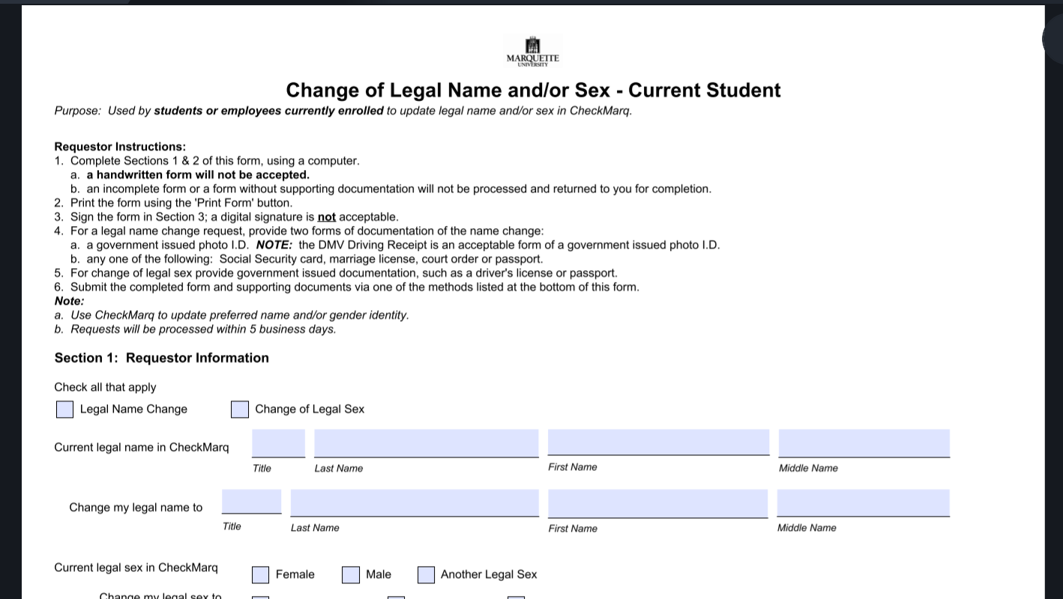
Step 4. Submit your document by one of the following methods.
Hand Deliver: Marquette Central, Zilber Hall, 121, 1250 West Wisconsin Avenue, Milwaukee, WI 53233 Mail: Marquette University, Zilber Hall, 221, P.O. Box 1881, Milwaukee, WI 53201-1881
Email: otrdocs@marquette.edu

Changing Your Legal Name: Mobile
Step 1. Log into CheckMarq. In the “Profile” section, click on Update info here.
Step 2. Click on “Personal Details” at the top.
Step 3. Click on the hyperlink labeled “Marquette Central” beneath the Names box under Instructions.
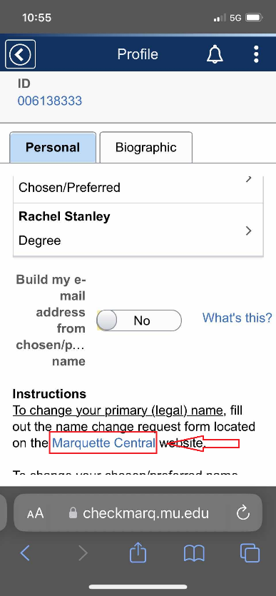
Step 4. Save the file to a location on your phone that you will be able to easily access. Open the PDF and fill it out electronically or print and fill it out.
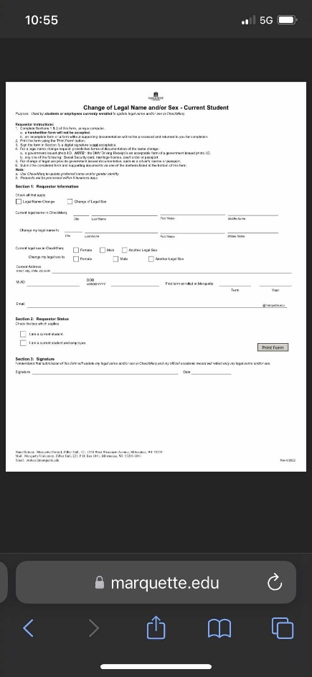
Step 4. Submit your document by one of the following methods.
Hand Deliver: Marquette Central, Zilber Hall, 121, 1250 West Wisconsin Avenue, Milwaukee, WI 53233 Mail: Marquette University, Zilber Hall, 221, P.O. Box 1881, Milwaukee, WI 53201-1881
Email: otrdocs@marquette.edu

