How to Get a New Marquette ID Step-by-Step
- First, follow our tutorial on Changing Your Preferred Name In CheckMarq. You cannot get a new ID without charge unless you do so.
- Bring your old ID card, you will be charged a replacement fee without it.
- Go to Union Station located in the ground level of the Alumni Memorial Union (AMU). Enter in the east entrance, by the Brew coffee shop and Spirit Shop. Head to your right past the Town Bank, and then turn right again.
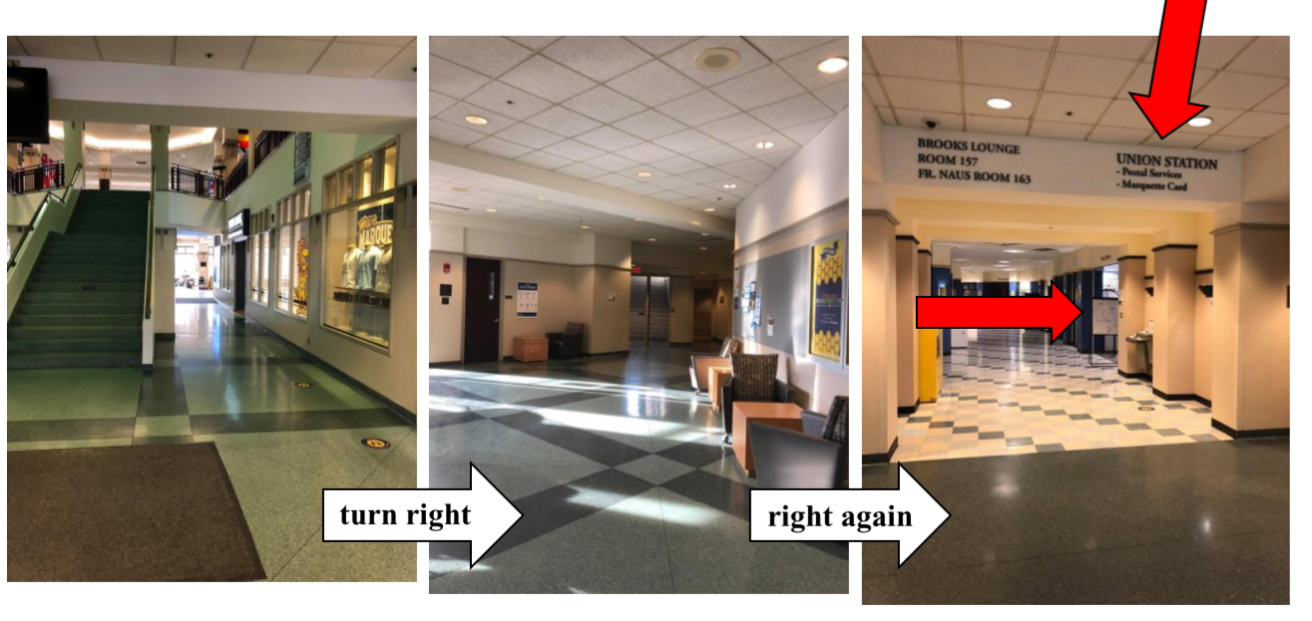
- The Union Station will be on your right side, sharing space with postal services.
- Inform someone working at the station that your name has been changed and you would like a new ID. If you would like to have your picture retaken for the new ID, inform them of this as well (but a new picture is not required). They will take your old ID and print a new one for you.

