Al McGuire Center

The Al McGuire Center is the home of the Marquette Women’s Basketball team, The Men’s Basketball practice court, Women’s Volleyball, and sports training facilities as well as Marquette sports offices.

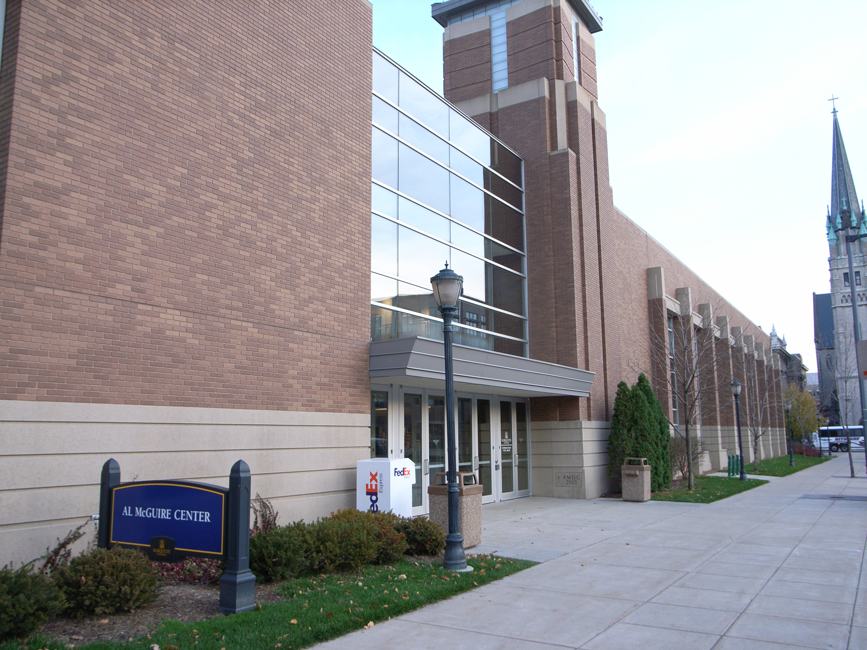

(Arrow points North)

Accessibility

Entrance
Wheelchair accessible, Automatic Doors
(Pictured)

Women’s Bathrooms
Located in the arena concourse between the men’s bathrooms. (2 per side)
Men’s Bathrooms
Located in the arena concourse at the ends of either side
Elevator Location
Through the main door and to the right. Across the lobby from the information desk.

