Import LockDown Browser/Monitor Module into D2L Course Site

Download Zip File
- Firefox is the preferred browser for D2L Brightspace.
- Click on the link to download the zip file.
- Click OK to open as Save File.
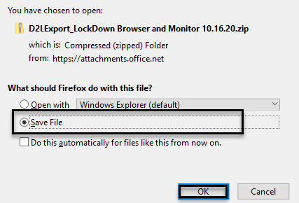
- The file will appear in the upper right-hand corner of the page. (Do not unzip file.)
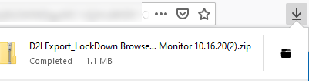

Import Zip File
- Select Edit Course of main course navigation bar.
- Click Import/Export/Copy Components found under Site Resources.
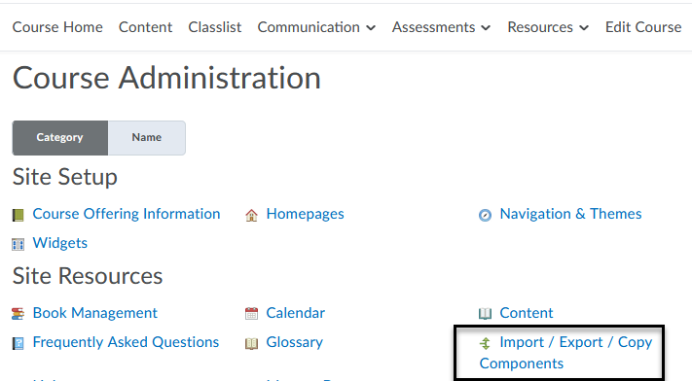
- Select Import Components and click Start.
- Drag and drop the zip file from the download folder of your computer or use the Upload button to find the file to select.
- Click Import All Components. A message indicating the package was successfully imported will appear.
