How to Cut and Trim Videos in the Photos App
Navigate to your “Photos app”. If having trouble locating it, you may always search for it in the search bar at the bottom left of your screen.
Once in the app click the “New Video” button at the top right of the screen.
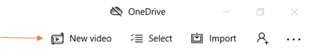
Select the “New Video Project” option that drops down.

Next, Name your video project and select “OK”.
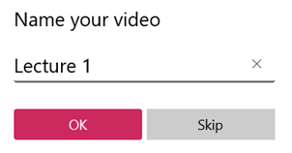
In the project library (top left window of the screen) select “Add”
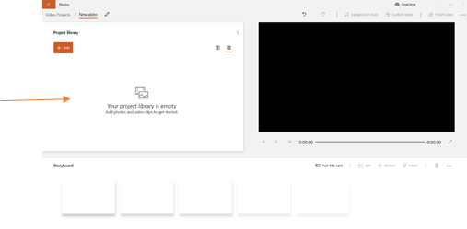
You will have the option to “add a file from your PC”, from “your collection”, or from “the web”.
Select to “add a file from your PC”.

Now locate the video you would like to edit in your files, click on it, and select “open”
The video file will be placed in your project library.
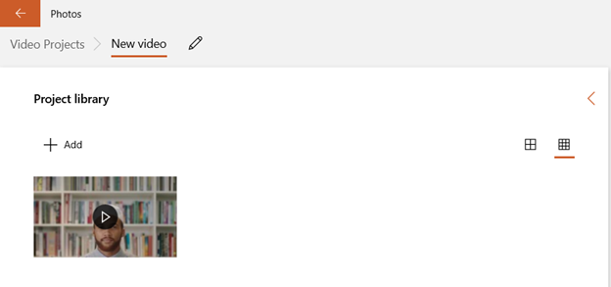
Now that your video is in the Storyboard there will be a list of editing options just above it.

To cut your video into two separate clips, click on your video in the timeline to select it and select the “Split” option.
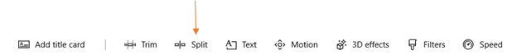

This will bring you to a window where you can scroll through your video to the point you would like to split it at. On the right you can also see the length that the two clips would be, once split. When you find the point you would like to split your video, click “done” at the bottom right of the screen.
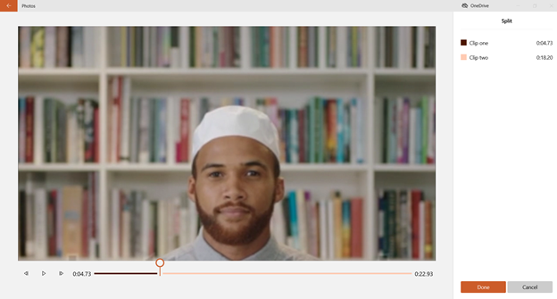
After clicking “Done you will notice that now there is two clips in your Storyboard.
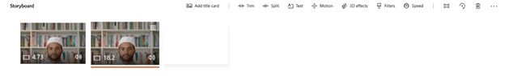
Now you have two clips, but if left like this the video will still play the same as before. In order to trim part out of the middle where you made the cut you will need to use the Trim tool.

First, select the clip you would like to trim by clicking on it, next click the trim tool. This will bring you to a window where you can roll the curser back on the front or back determining where the clip will start or end.
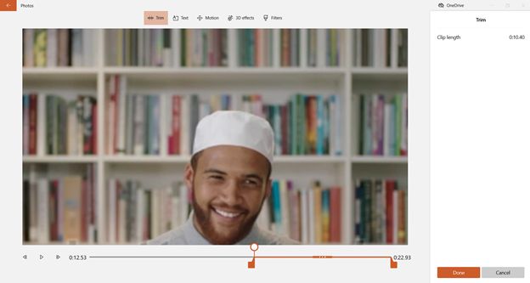
Once you get the clip to the point that you would like it you can simply click “Done” and the clip will be trimmed. You can preview your finished video in the preview window at the top right.
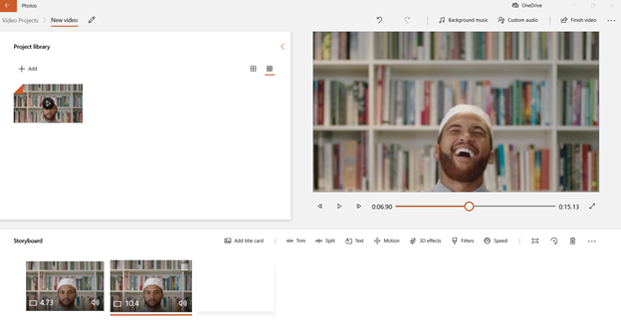
If everything looks good then it is time to export the final video. Click the “Finish Video” button at the top right of the screen.

Then, select the quality you would like to export it at. We recommend using the 1080p option.
Click Export.
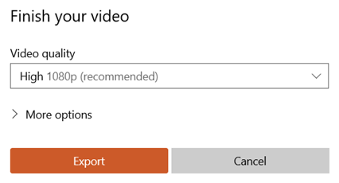
Locate the folder or area on your computer where you would like for the video to save and then click export once again.
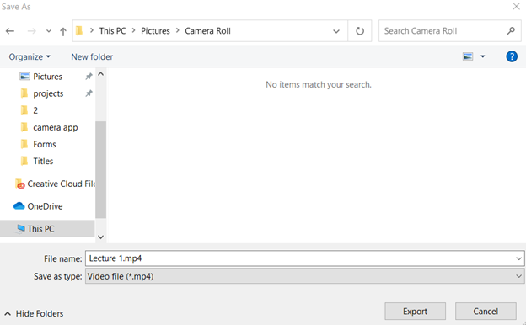

After this your file will begin exporting. This could take quite a bit of time depending on the video length. The longer the video, the longer it will take to export.
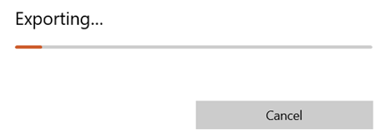

Additional Resources for Editing Videos:
- Microsoft Stream (included in your Office 365 Suite): Allows Video Trimming Only
- YouTube Video Editor: Allows basics in sound and trimming videos.
- Camtasia: Screen Recorder and Video Editor which is simple and easy to use. There is also a free trial that you can try prior to purchase. Check with your department to see if anyone has a license to this software.
- Adobe Premiere Pro: Professional Editing Software which can be purchased on an individual basis. Best for those with previous editing experience.

