Follow these steps to check into an event:
- Download and install the Modern Campus Presence app at the Play Store or Apple Store.
- Find Marquette University on the Find my Campus screen.
- Then log in with your Marquette email and password.
- Click the “Events” icon at the bottom, and then “Host Events.”
- Choose “Use a PIN”.
- Then enter the event pin and click “Submit.”
 | 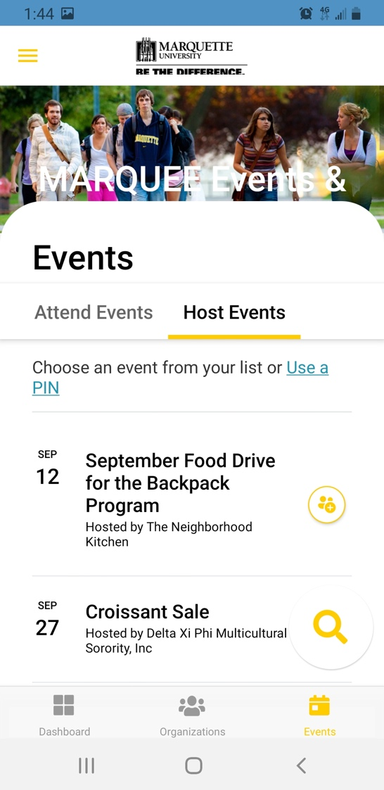 | 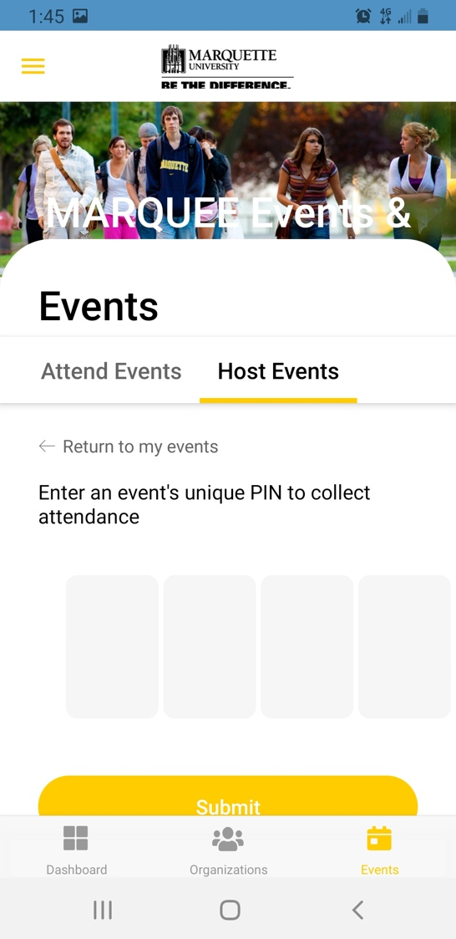

Follow these steps to check others into your event:
1. Open the Modern Campus Presence app.

2. Tap the three yellow lines at the top left of the screen. | 4. Choose “Host Events” and “Use a PIN”. | - Choose “Manual Entry.”  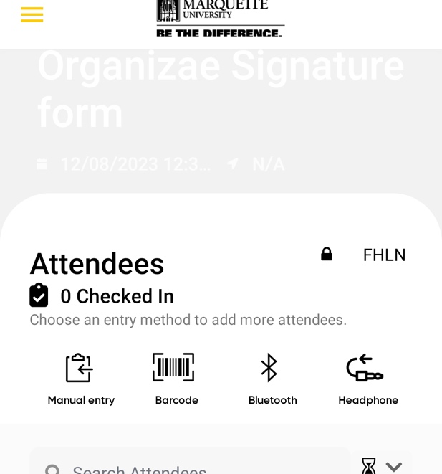
3. Choose “Collect Attendance” | 5. Then enter your pin and click “Submit.”  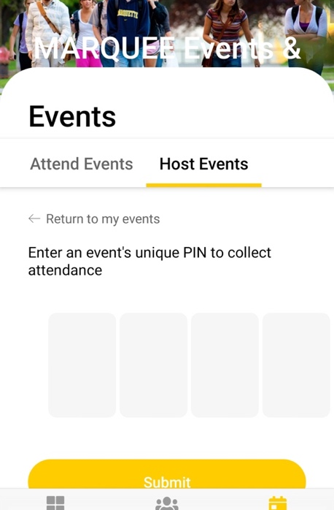 | - Enter in person’s MUID or Marquette email and submit.

